**Zoom presentation directions**

**Poster presentation**

* When you click on the Zoom link for the poster session (this link will be e-mailed to you), you will enter the main session. If this does not work, you may need to download Zoom.
* Upon entering the Zoom session, the host will automatically move you into your designated breakout room. If not, you can press the chat button and ask to be moved into your breakout room.
* Once in your breakout room, you can simply click on the green Share Screen icon located at the bottom of your Zoom window (see below). This will show you all documents you currently have open on your desktop, and you can click on you then click on your presentation, then click on the blue Share button.



* Your audience can now see the document that on your screen has a yellow-green line around it.

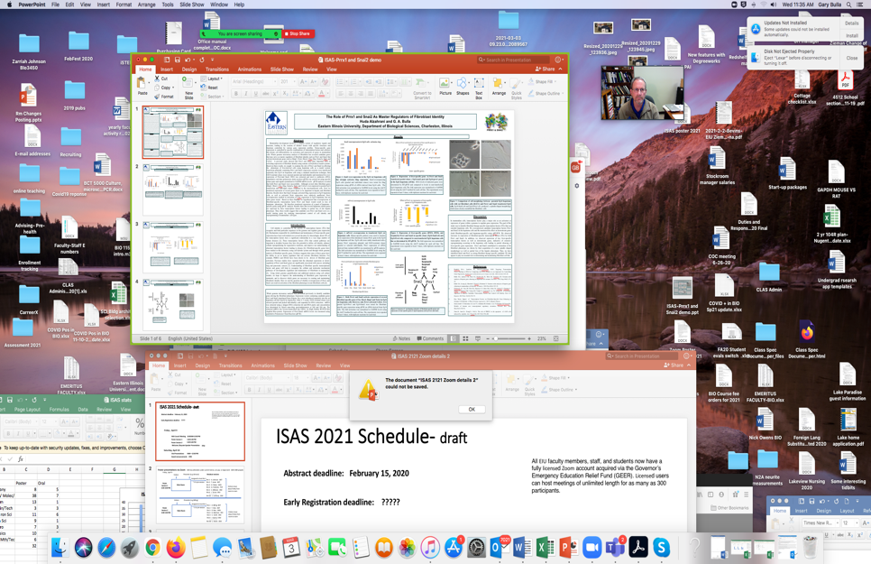

* Presentation pointers:
  + Make sure that you are presenting in a location with strong connectivity- universities, colleges, libraries and other institutions are normally good choices.
  + Enter the session at least *30 minutes* before your session starts. This will allow any issues to be handled prior to the session.
  + Make sure you are unmuted!
  + If using Powerpoint, it is suggested that you click on the “Slide Show” function in Powerpoint to maximize the screen size. If you have another slide format such as Prezi, that is fine, just make sure the audience can see your poster.
  + *Keep your presentation short*! You can then interact with visitors and ask if they would like a quick run through. If yes, provide a **2-3 minute overview** starting with overall goal, your approach, a very brief description of your results, and your conclusions. This part should be carefully rehearsed and very succinct. If the viewers want clarification, questions will be asked.
  + You may want you break your presentation down further into 2-3 additional slides to amplify images. However, these should not make your presentation any longer. When done, you should circle back to the whole poster.
  + Keep the large poster slide showing as much as possible.
  + During the session, participants (including poster judges) will be entering and leaving your breakout room, but do not let that distract you.
  + Stay with your session (don’t go out for coffee).
  + Interact with new-comers as appropriate.
  + If you need help, click the Stop Screen Share icon and then click on the blue Leave Room icon located on the lower right corner of the screen. This will take you to the main room and you can ask your question verbally or through the chat function.