**Zoom presentation directions**

**Oral presentation**

* When you click on the Zoom link for the oral presentation sessions (this link will be e-mailed to you), you will enter the main session. If this does not work, you may need to download Zoom.
* Upon entering the Zoom session, presenters can click on the breakout room icon and select the desired room. If you have a question, you can ask the session host in the main room.
* Once in a breakout room, you should introduce yourself to the breakout room manager. This person will ensure that you will be able to share your presentation at the scheudleed time. In the pre-session, you may ask to preview your presentation for a quick audio and video check.
* Once it is your time to present, you can simply click on the green Share Screen icon located at the bottom of your Zoom window (see below). This will show you all documents you currently have open on your desktop, and you can click on your presentation, then click on the blue Share button.



* Your audience will now see the document on your screen has a yellow-green line around it.

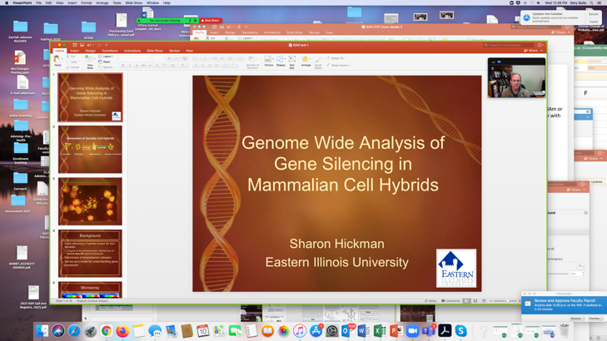

* If using Powerpoint, click on the “Slide Show” function to maximize the screen size. If you have another slide format such as Prezi, that is fine. Just make sure the audience can see what you hope they can see.
* Presentation pointers:
  + Make sure that you are presenting in a location with strong connectivity- universities, colleges, libraries and other institutions are normally good choices.
    - *Note:* *If your connectivity is poor, the moderator may choose to show your previously submitted narrated presentation during your time slot.*
  + Enter the session at least *20- minutes* before your session starts. This will allow any issues to be handled prior to the session.
  + Make sure you are unmuted when presenting.
  + *Keep your presentation to* ***8-12 minutes****.* This part should be carefully rehearsed. This will leave time for a question and answer period. We have scheduled 20 minutes per session as a buffer for technical difficulties.
    - *If you are going long, the moderator or room manager may alert you to finish up quickly*
  + When your presentation is complete, leave your presentation showing until the completion of questions.
  + Once the Q and A is done, click on the red Stop Share button to exit your presentation.